Module 1 – Foundation

THEORY EXERCISE:
- What is a HTTP?
- HTML stands for Hyper Text Markup Language
- HTML is the standard markup language for creating Web pages
- HTML describes the structure of a Web page
- HTML consists of a series of elements
- HTML elements tell the browser how to display the content
- HTML elements label pieces of content such as "this is a heading", "this is a paragraph", "this is a link", etc.
- We can create a static website by HTML only
- HTML is a markup language rather than programming language
<html>
<head>
<title>Page Title</title>
</head>
<body>
<h1>My First Heading</h1>
<p>My first paragraph.</p>
</body>
</html>

Explanation of example:-
- The <!DOCTYPE html> declaration defines that this document is an HTML5 document
- The <html> element is the root element of an HTML page
- The <head> element contains meta information about the HTML page
- The <title> element specifies a title for the HTML page (which is shown in the browser's title bar or in the page's tab)
- The <body> element defines the document's body, and is a container for all the visible contents, such as headings, paragraphs, images, hyperlinks, tables, lists, etc.
- The <h1> element defines a large heading
- The <p> element defines a paragraph

2 What is a Browsers? How they works?
- A web browser is a software application that lets users access and view content on the World Wide Web.
- It essentially acts as a gateway between the user and the web, allowing them to navigate, interact, and experience online information.
How it works:
- 1. User Request:
The process begins when a user enters a website's address (URL) into the browser's address bar or clicks a link.
- 2. DNS Resolution:
The browser then uses the Domain Name System (DNS) to translate the website's domain name (like google.com) into an IP address, which is the unique numerical address of the server hosting the website.
- 3. HTTP Request:
The browser sends an HTTP (Hypertext Transfer Protocol) request to the server, asking for the website's content.
- 4. Server Response:
The server receives the request and, if the website exists, sends back the requested content in the form of files like HTML, CSS, and JavaScript.
- 5. Rendering:
The browser then uses a rendering engine to interpret these files and display them as a web page on the user's screen.
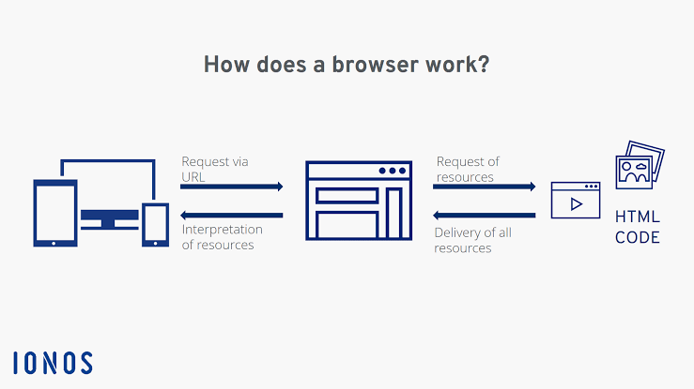
3 What is Domain Name?
- A domain name is the user-friendly, easy-to-remember address that represents a website or online service on the internet.
- It's the part you type into your browser to access a specific web location, like "www.example.com".
- Domain names are like street addresses for the internet, making it easier to navigate the web than using numerical IP addresses.
- Here's a more detailed explanation:
- What it is:
A domain name is a unique string of text that identifies a specific resource on the internet, such as a website, email server, or other online service.
- How it works:
When you type a domain name into your browser, your computer sends a request to a Domain Name System (DNS) serverThe DNS server then translates the domain name into the corresponding IP address, which is the numerical address that computers use to communicate.
- Examples:
Common examples of domain names include "google.com,""wikipedia.org," and "facebook.com". 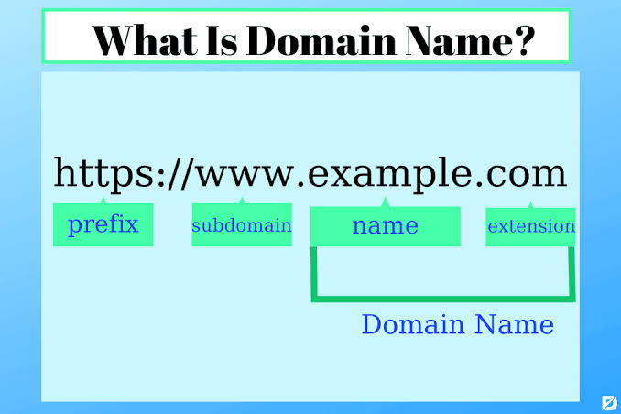
4 What is hosting?
